<======================================================================>

**LAMP Wordpress + PhpMyAdmin Part 2/2**

<======================================================================>

**Install MariaDB:**

apt-get install mysql-server

Se não aparecer rode:

apt-cache search mysql-server

apt-get install default-mysql-server

**Checkout service status:**

systemctl status mariadb

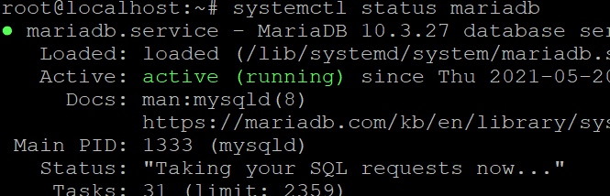

mysql -u root -p

You will be prompted for the password you set for the MySQL root account when you installed the software.

DATABASE + USER + PASSWORD  
NÃO ESQUECER!

SERÁ USADA PARA O PHPMYADMIN E WP-CONF

First, we can create a separate database that WordPress will control

Para facilitar o entendimento vamos uma database chamada: **wordpres**

MariaDB [(none)]> CREATE DATABASE wordpress DEFAULT CHARACTER SET utf8 COLLATE utf8_unicode_ci;

We are going to create this account, set a password, and grant access to the database we created. We can do this by typing the following command. Remember to choose a strong password here for your database user:

MariaDB [(none)]> GRANT ALL ON wordpress.* TO 'wordpressuser'@'localhost' IDENTIFIED BY 'minhasenhaqui';

You now have a database and user account, each made specifically for WordPress. We need to flush the privileges so that the current instance of MySQL knows about the recent changes we’ve made:

MariaDB [(none)]> FLUSH PRIVILEGES;

MariaDB [(none)]> EXIT;

Criar o virtualhost com rewrite url:

nano /etc/apache2/sites-available/wordpress.conf

<Directory /var/www/wordpress/>

AllowOverride All

</Directory>

NameVirtualHost *:80

<VirtualHost *:80>

ServerName wpp.gpnote.tech

DocumentRoot /var/www/wordpress

</VirtualHost>

Enabling the Rewrite Module

Next, we can enable mod_rewrite so that we can utilize the WordPress permalink feature:

a2enmod rewrite

**Rode o comando abaixo para habilitar os novos sites**

a2ensite meus-sites.conf

**Rode o comando abaixo para desabilitar o arquivo padrão:]**

recomendado se for usar apenas 1 site para o servidor

a2dissite 000-default.conf

Para ativar a listagem remover o /var/www/html para  
DocumentRoot /var/www  
 nano /etc/apache2/sites-enabled/000-default.conf

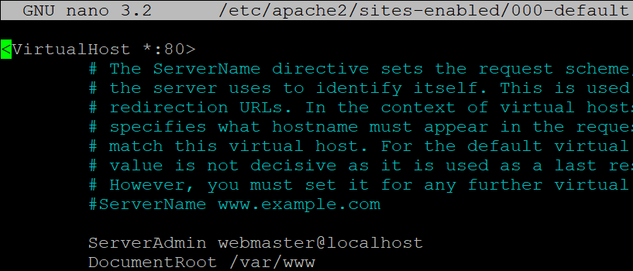

**Enabling the Changes**

**Before we implement the changes we’ve made, check to make sure we haven’t made any syntax errors:**

apache2ctl configtest

**Restart Apache to implement the changes:**

**systemctl restart apache2**

**Downloading WordPress**

cd /tmp

curl -O https://wordpress.org/latest.tar.gz

tar xzvf latest.tar.gz

**We will be moving these files into our document root momentarily. Before we do, we can add a dummy .htaccess file so that this will be available for WordPress to use later.**

**Create the file by typing:**

touch /tmp/wordpress/.htaccess

We’ll also copy over the sample configuration file to the filename that WordPress actually reads:

cp /tmp/wordpress/wp-config-sample.php /tmp/wordpress/wp-config.php

We can also create the upgrade directory, so that WordPress won’t run into permissions issues when trying to do this on its own following an update to its software:

mkdir /tmp/wordpress/wp-content/upgrade

Now, we can copy the entire contents of the directory into our document root. We are using a dot at the end of our source directory to indicate that everything within the directory should be copied, including hidden files (like the .htaccess file we created):

sudo cp -a /tmp/wordpress/. /var/www/wordpress

Configuring the WordPress Directory

Permissão de file e diretórios:

chown -R www-data:www-data /var/www/wordpress

find /var/www/wordpress/ -type d -exec chmod 750 {} \;

find /var/www/wordpress/ -type f -exec chmod 640 {} \;

Arquivo de configuração do WordPress

Gerar as chaves e copiar para o bloco de notas

curl -s https://api.wordpress.org/secret-key/1.1/salt/

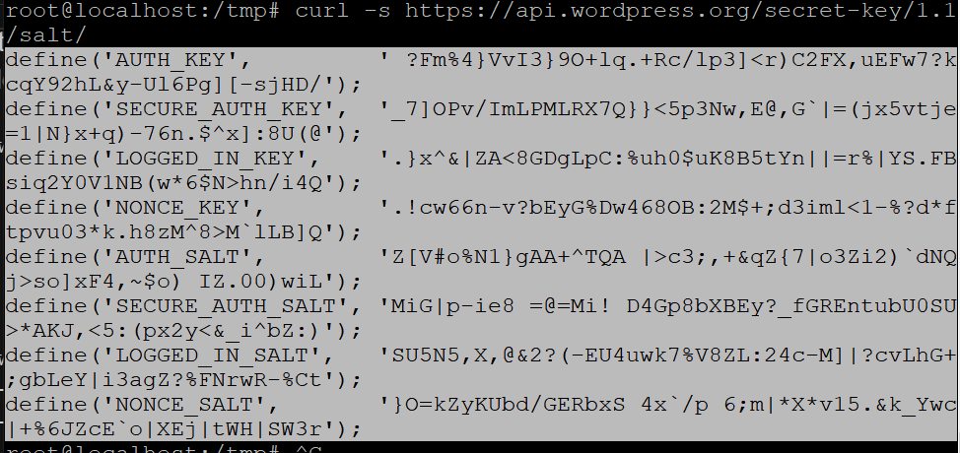

Now, open the WordPress configuration file:

nano /var/www/wordpress/wp-config.php

E substitute as keys pelas que foram geradas

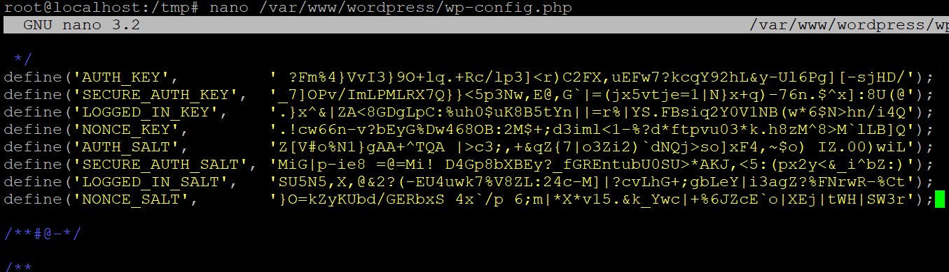

Edite também:

DB_NAME  
DB_USER  
DB_PASSWORD

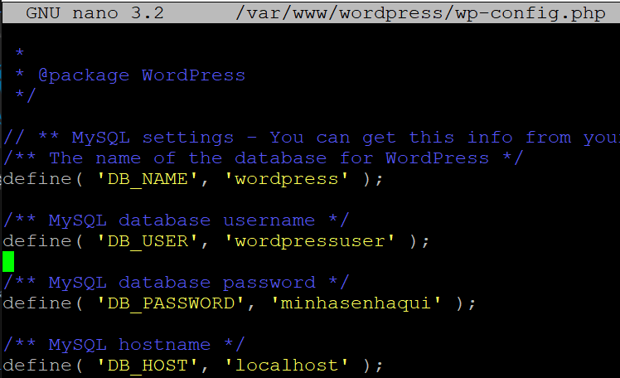

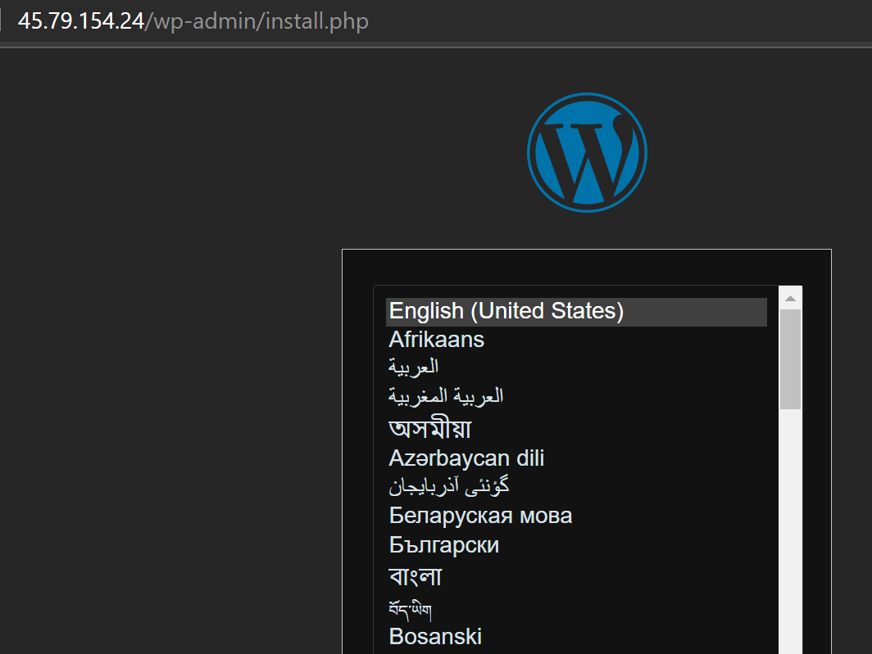

**Ref:** [**How To Install WordPress with LAMP on Ubuntu 18.04 | DigitalOcean**](https://www.digitalocean.com/community/tutorials/how-to-install-wordpress-with-lamp-on-ubuntu-18-04)

**INSTALL PHPMYADMIN**

**Cd /var/www**

**wget** [**https://files.phpmyadmin.net/phpMyAdmin/5.1.0/phpMyAdmin-5.1.0-all-languages.zip**](https://files.phpmyadmin.net/phpMyAdmin/5.1.0/phpMyAdmin-5.1.0-all-languages.zip)

**Apt-get install unzip**

**unzip phpMyAdmin-5.1.0-all-languages.zip**

ls -lh /opt

root@localhost:/var/www# mv -v /var/www/phpMyAdmin-5.1.0-all-languages /opt/phpMyAdmin

renamed '/var/www/phpMyAdmin-5.1.0-all-languages' -> '/opt/phpMyAdmin'

chown -Rfv www-data:www-data /opt/phpMyAdmin

nano /etc/apache2/sites-available/phpmyadmin.conf

<VirtualHost *:9000>

ServerAdmin webmaster@localhost

DocumentRoot /opt/phpMyAdmin

<Directory /opt/phpMyAdmin>

Options Indexes FollowSymLinks

AllowOverride none

Require all granted

</Directory>

ErrorLog ${APACHE_LOG_DIR}/error_phpmyadmin.log

CustomLog ${APACHE_LOG_DIR}/access_phpmyadmin.log combined

</VirtualHost>

<salvar>

**/etc/apache2/ports.conf**

**Adicionar a porta 9000**

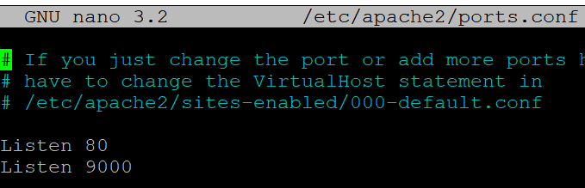

**Ativar o virtualhosto do phpmyadmin and restart Apache2**

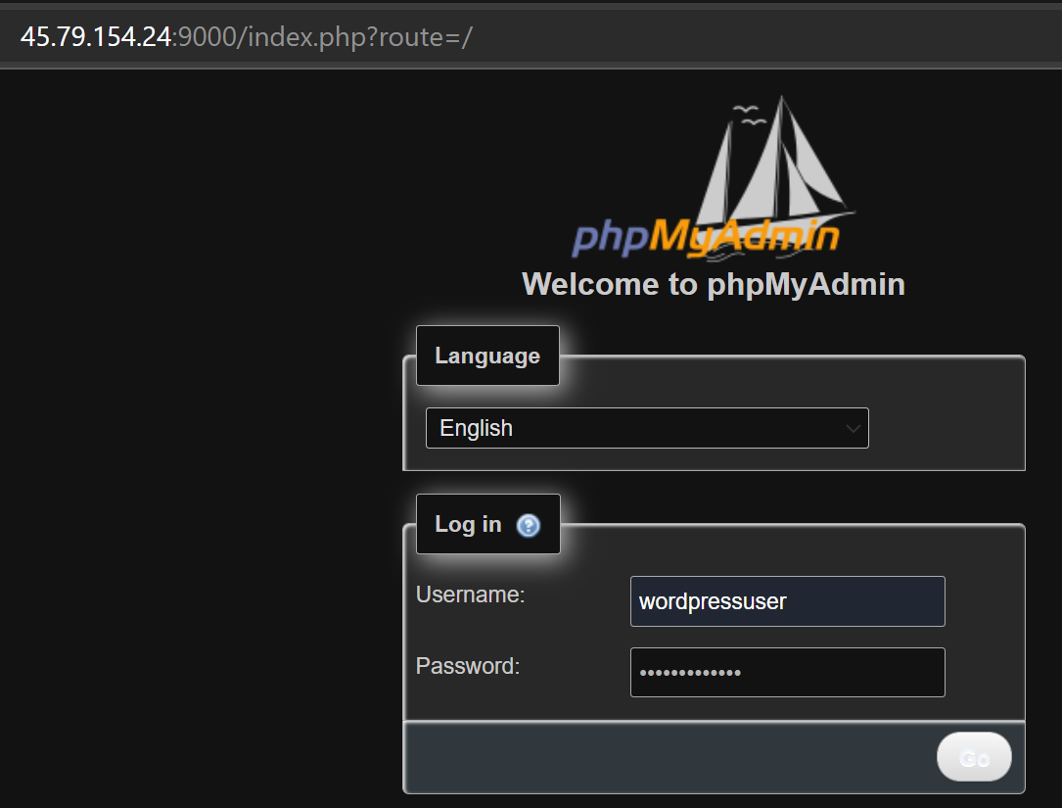

Ref: [Installing phpMyAdmin on Debian 10 – Linux Hint](https://linuxhint.com/install_phpmyadmin_debian_10/)